**Project Scope**

**In-Scope**

|  |  |
| --- | --- |
| 1. | Identify patterns with fraudulent activities. |
| 2. | Analyze the data using linear and logistic regression. |
| 3. | Use the ANN model to create predictions. |
| 4. | Build a robust fraud detection system to analyze the data set. |
| 5. | Give an option to predict whether this dataset is fraudulent or not in the system. |

**Out-Scope**

|  |  |
| --- | --- |
| 1. | Facilities the users in multiple languages. |
| 2. | Creating an automatic alert system to inform the parties. |
| 3. | When the system detects unusual activities or transactions alert the user. |

**Process-1**

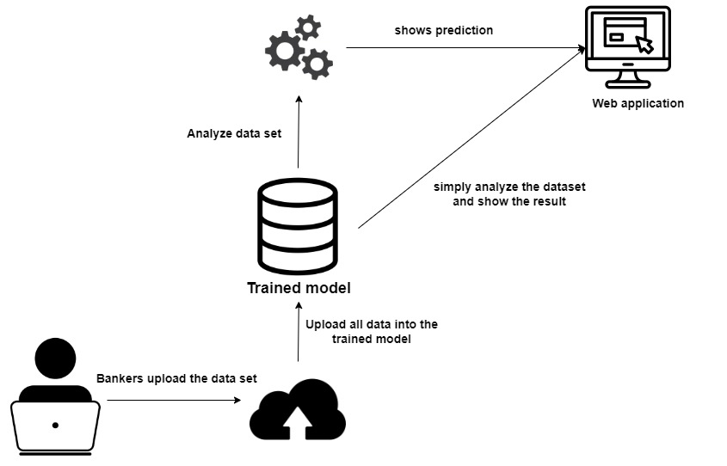

**Process-2**

**Process-1**

* A banker will upload the dataset into a system and start the process in a trained model.
* The trained model uses linear regression and logistic regression to analyze the dataset.
* Displays all the analyses using graphs and charts, and it will give a summary to the user to understand the dataset properly.
* The trained model uses the ANN(Artificial Neural Network) model to predict the fraudulent.
* ANN model identifies fraudulent transactions based on historical data and transaction features.

**Process-2**

* This is a web application. First, the user inputs the dataset into a system.
* After uploading data into the trained model it starts to analyze it.
* The application gives two main options. Analyze dataset and prediction and the others are delete dataset, view dataset.
* In the analysis part, it will simply analyze the dataset.
* In the prediction part, it will predict whether the dataset is fraudulent or not, using ML(Machine Learning) techniques.

**Resource requirements**

**Hardware requirements**

* CPU (intel core i7th generation processor or high) – To get more powerful performance.
* 16GB RAM or high – to train heavy ML algorithms.
* Storage (minimum 256GB SSD/ 1TB HDD) - To store data.

**Software requirements**

* Python - The primary language used to create the proposed system is Python, which is particularly user-friendly in terms of error handling and library support.
* PyCharm Enterprise - used for developing proprietary and commercial software.
* HTML- To structure the webpage.
* CSS – used to style and layout web pages.
* JavaScript – used for scripting the webpage.
* MS Word – To write documents.
* TensorFlow - For pre-processing and training the model.
* Windows Operating System – To handle huge computational functionalities.
* SPSS - To run linear regression with multiple dependent variables (Multivariate regression)

**Data Requirements**

We selected the appropriate dataset from Kaggle. This dataset contains credit card transactions from 2023 that cardholders in Europe made. More than 550,000 records are included in the data, which has been anonymized to protect the cardholders' identities.

This is used to train the system to identify fraudulent transactions based on historical data and transaction features.

**Skill Requirements**

* Searching for information
* Report writing
* Critical thinking
* Time management
* Problem-solving
* Planning and scheduling